

# Possum Sero! Phone

## Type of device: Landline - Standard

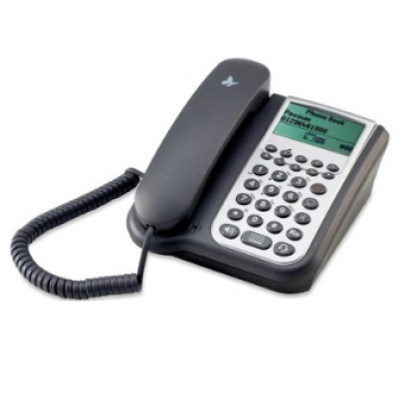

Button Type : Physical Keypad

Average Price : $1500 as of 17 06 2021

## Accessibility Features:

### Cognitive

Voice Notes

### Hearing Impairment and Deaf

* Hearing Aid Microphone Coupling
* Hearing Aid Telecoil Coupling

Visual Alerts - Incoming Calls

### Vision

* Key Marker – Raised '5'
* Key Numbers - Standard Layout
* Key Press - Vibration or Click

Voiced Menus

### Physical

* Automatic Redial
* Flat Back for Table Top Operation
* Guarded/Recessed Keys
* Headset - plug connected
* Physical Dialling Keys

Speaker-phone option

## How and where to get it from?

You can buy this phone from [Technical Solutions Australia.](http://www.tecsol.com.au/sero/index.html)

## More information is available on:

[Possum Sero! Webpage (UK)](http://www.possum.co.uk/products/sero/)

[Possum Sero! Phone Manual (PDF Download)](https://www.manualslib.com/manual/920729/Possum-Sero.html)

[Possum Sero! Phone Video](https://www.youtube.com/watch?v=Ks6fVgYkJl4)